Northside News, March 2020
The Women’s Issue
In honor of Women’s History Month, we are featuring stories about some of the many women who built and sustain the Northside, Pine Knolls, and Tin Top communities. Some of the shining lights-- including Jackson Center namesake, Ms. Marian Cheek Jackson-- fought for social justice, kept the faith and made sure that kids coming up knew their history and respected their elders and themselves. This issue is a tribute to all of them.

That man over there says that women need to be helped into carriages and lifted over ditches and to have the best place everywhere. Nobody ever helps me into carriages, or over mud-puddles or gives me any best place! And ain’t I a woman? - Sojourner Truth, 1851

Sisters In Spirit and Song
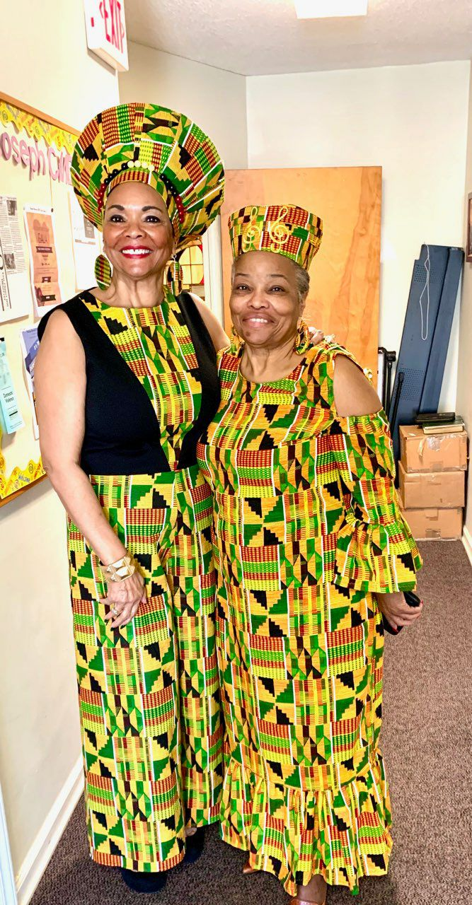
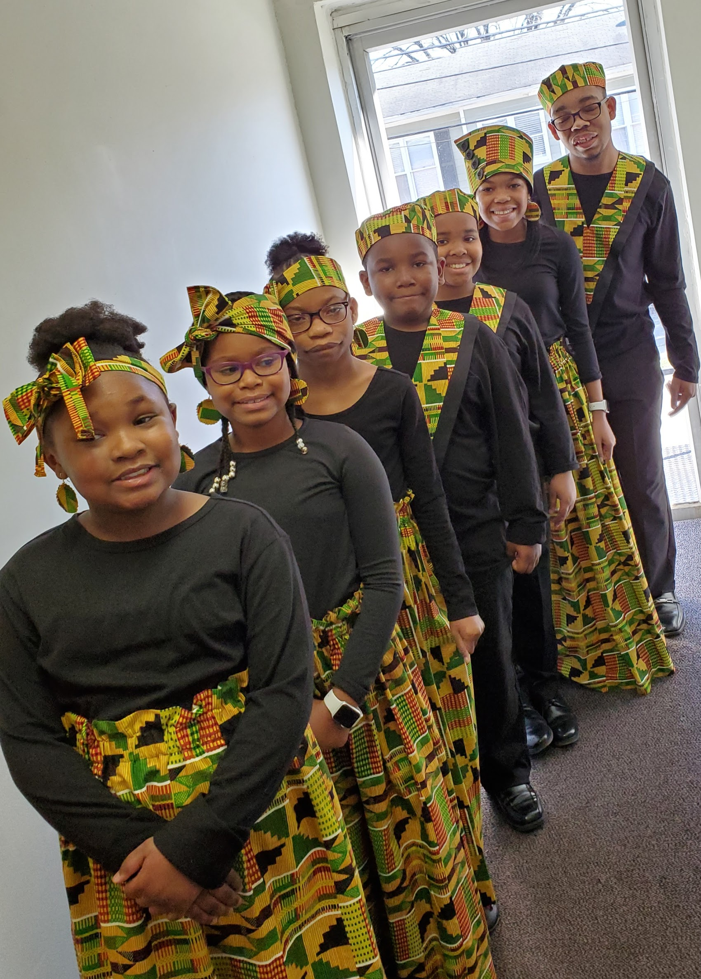
When you first meet Ms. Roxy and Ms. Nissie together it is immediately apparent that they are close by the way they complete each other’s sentences. Only eleven months apart in age, they grew up going to church every Sunday, feeling the comfort of being part of a faith community. And now they are making sure the children at their church, St. Joseph C.M.E., experience the same love.
When the church needed a new choir director, the pastor asked Ms. Nissie, and she knew right away who to call. Ms. Roxy says, “I come up with the songs, and we collaborate. We come together.” Ms. Nissie, for her part, sews the beautiful garments the children wear when they perform. The boys’ and girls’ colorful outfits are complete with originally-designed hats, head wraps, and even matching jewelry.
Just as they were “raised by a village,” Ms. Roxy and Ms. Nissie want to share their faith and the transformative spirit of music with the children in the Youth Choir. Ms. Roxy explains, “I always tell them. You’re not singing for me. You’re giving glory to God. And the reason why you’re giving glory to God is that you have parents and you have what you need. Let’s sing praises to God and give him honor, glory, and praise for what he does for us and for what he’s going to do with us. We are blessed; the kids love us and feel we are going to treat them right. We really are one big happy family.”

_____________________________________________________

Sisterly Love, Sisterly Courage

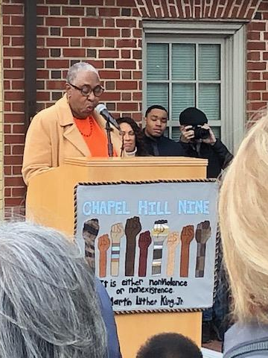
“They were fearless. They were young, gifted and Black.”
With these words, Ms. Esphur Foster helped dedicate a new monument in front of the old Colonial Drug Store on Franklin Street where her brother, Harold, and eight other students were arrested for participating in sit-ins in 1960. Ms. Esphur, like her brother, has a fighting spirit and a gift for words:
Welcome and thank you for joining us for this well deserved acknowledgement of courageous and fearless young men - they were the Chapel Hill Nine. When you are 80 as I am now you realize that actually, they were just babies - 16,17 and 18 years of age. On February 28, 1960 these babies had the audacity or as we black folks like to say had the nerves to address a societal norm that had begun for us, the African-Americans, in 1619 when our ancestors were introduced into this foreign country at Jamestown, Virginia, to a world of inequality in all aspects of life, a world of slavery and then the era of Jim Crow.

They took the bull, Mr. Jim Crow, by the horns, and thus began a tussle that continues until this very day. Although it has taken sixty years for this acknowledgement, to come to fruition, as the saying goes, "it is better late than never!"

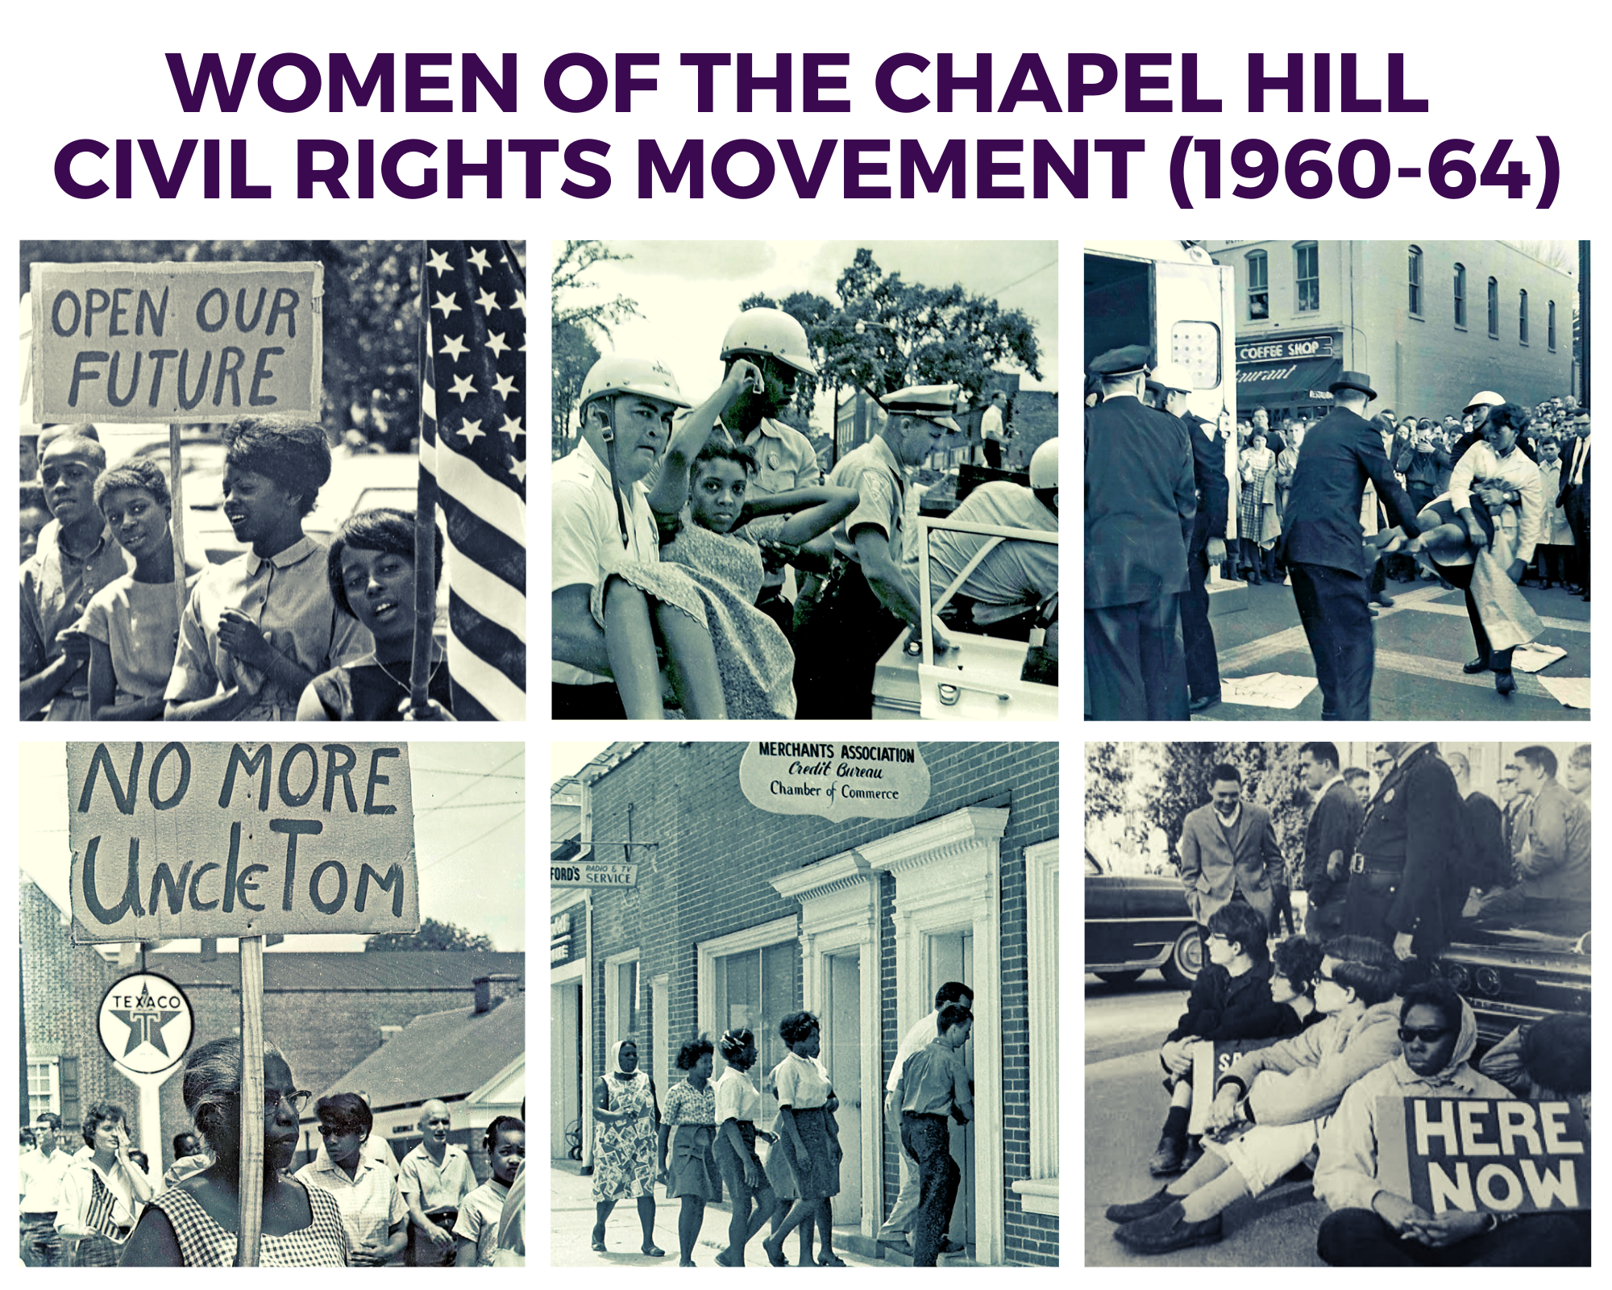
Top row: Ms. Clementine Self and Ms. Ruby Farrington lead march; Ms. Euyvonne Cotton is arrested at Merchants Assoc. protest; Ms. Ruby Farrington is arrested on Franklin St. Bottom row: Ms. Avery Brewer joins march; protestors enter Merchants Assoc., Ms. Nettie Burnette sits-in on Franklin St. You can find these original photos on the Jackson Center website: www.archive.jacksoncenter.info
_____________________________________________________
Celebrating Black Women Teachers
When the Freedmen’s Bureau and the American Missionary Association opened the first schools for African Americans immediately after the Civil War, they didn’t just bring in white teachers from the North. They also relied on Southern black women to teach millions of pupils of all ages. Women like Sara Stanley, born free in New Bern and educated at Oberlin College in Ohio, returned to the south to take up the task of educating formerly enslaved people. Stanley taught in Norfolk, Virginia, sometimes leading classes of nearly 100 people who wanted to learn to read and write and who had fled behind Union lines to have that opportunity.

A few decades later, black women were at the forefront of efforts to establish black high schools and colleges. Women like Mary McLeod Bethune opened a boarding school for black girls in 1904, selling sweet potato pies to raise money to keep its doors open. Her school later became Bethune-Cookman College. In 1908, Nannie Helen Burroughs opened the National Training School in Washington D.C., which welcomed African American women into its classrooms in the evenings after working hours. In 1937, Charlotte Hawkins Brown, then, President of Palmer Memorial Institute in Sedalia, NC, convinced Guilford County to open the first high school for rural African Americans in the state of North Carolina. Many of these schools taught African American history, long before it was a part of any state curriculum.

During segregation, black teachers laid the groundwork for Brown v. the Board of Education by documenting the inequality in schools, teaching their students Black History, and inspiring young learners to believe that their hard work and ability would create success. Those lessons were essential when students advocated for equality in the civil rights movement. While many black teachers lost jobs when the schools eventually integrated, others remained and influenced generations of black students. We don’t have to look any further than our own community to see the powerful impact of neighbors like Freda Andrews, Catherine Butler, Lillian Perry Robinson Cannon, Kimberly Fearrington, Frances Neal Hargraves, Pearl Lampley, Lucille McDougle, Sallie Pendergraft, Charlene Register, Addie Robinson, Clementine Self, Coretta Sharpless, Euzelle Smith, Patricia Farrington, and so many other women who have had an impact on education.

Do you have a story to tell about a teacher who inspired you? We would love to hear about it - contact the Jackson Center and let us know! - Kathryn Wall

________________
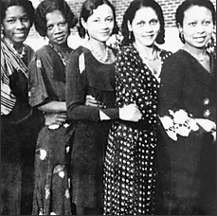
Sisterhood is Powerful!
In the month of March, Delta Sigma Theta Sorority, Inc. celebrates Sisterhood Month. Delta’s are predominantly African American college educated women committed to scholarship and service. March is a time that Sorors (Sisters) take the time to reflect on their purpose and celebrate each other. The Sorority’s purpose is to aid and support programs in local communities throughout the world. These women in their red and white have a 107-year history of leading women suffrage, social justice, mentoring and providing college scholarships to high school students. Collegiate and college graduate members seek to make their communities better places based upon Christian principles. Alpha Kappa Alpha, Zeta Phi Beta and Sigma Gamma Rho are also African American Greek sororities with similar values. Sorority life in the Black community continues building upon the rich histories they were founded upon.
- Phyllis Joyner is MCJC Director of Housing Justice and a member of Delta Sigma Theta Sorority, Inc.

Page 2:

One of Northside’s Own Applauded for Civil Rights Contributions
On Sunday, February 23, at Russell Memorial C.M.E. Church in Durham, Clementine Farrington Self was acknowledged and celebrated for fighting for equal rights for Blacks in Chapel Hill. Upon hearing of her participation and leadership in Chapel Hill’s struggle, the church received her with a rousing standing ovation. Her son James, daughter-in-law Jameria, father Mr. Joseph Farrington, and granddaughter Jada were present for the recognition.
___________________

Ms. Keith Edwards Featured in NOW Exhibit
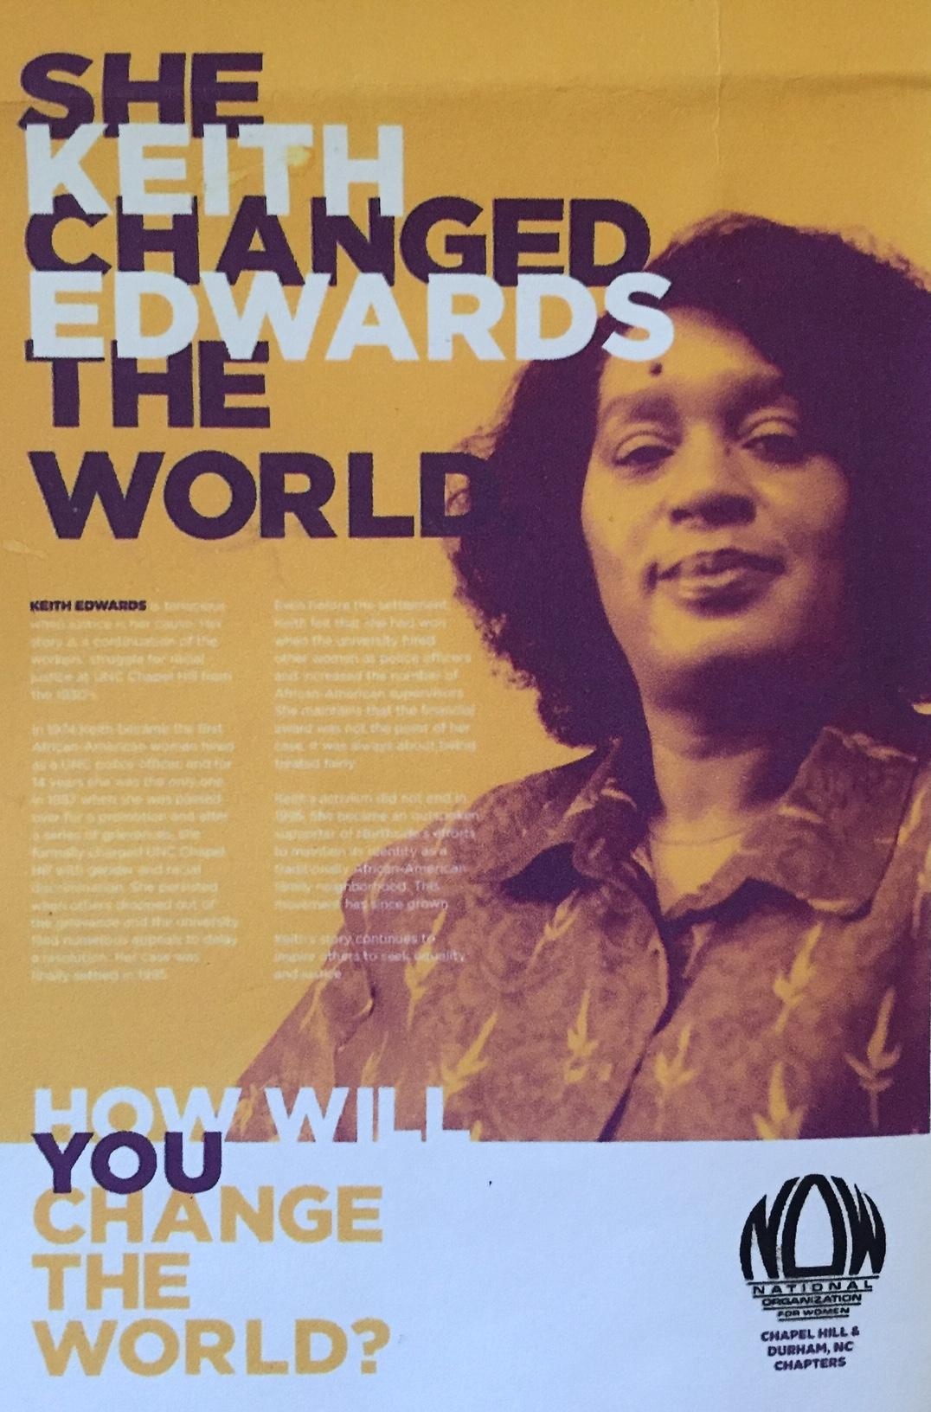
Instead of our usual monthly feature, the “Ask Keith” column, we would like to pay tribute to its author. Ms. Keith Edwards, a life-long resident of Northside, was one of ten women recognized in an exhibit sponsored by the Durham chapter of NOW (National Organization for Women) at the Chapel Hill Public Library. As the first Black police officer at UNC, Ms. Keith “changed the world” by fighting and winning a ten-year anti-discrimination lawsuit against the University. She is a fearless and tireless advocate for justice and is to many the heart and soul of Northside. Her legacy undoubtedly will inspire people for generations to come. Spread the word!
The “She Changed the World” exhibit is on display at the library throughout the month of March.

___________________________
Lil’ Dip’s Kitchen: Ms. Lane Council Carries on her Family Legacy
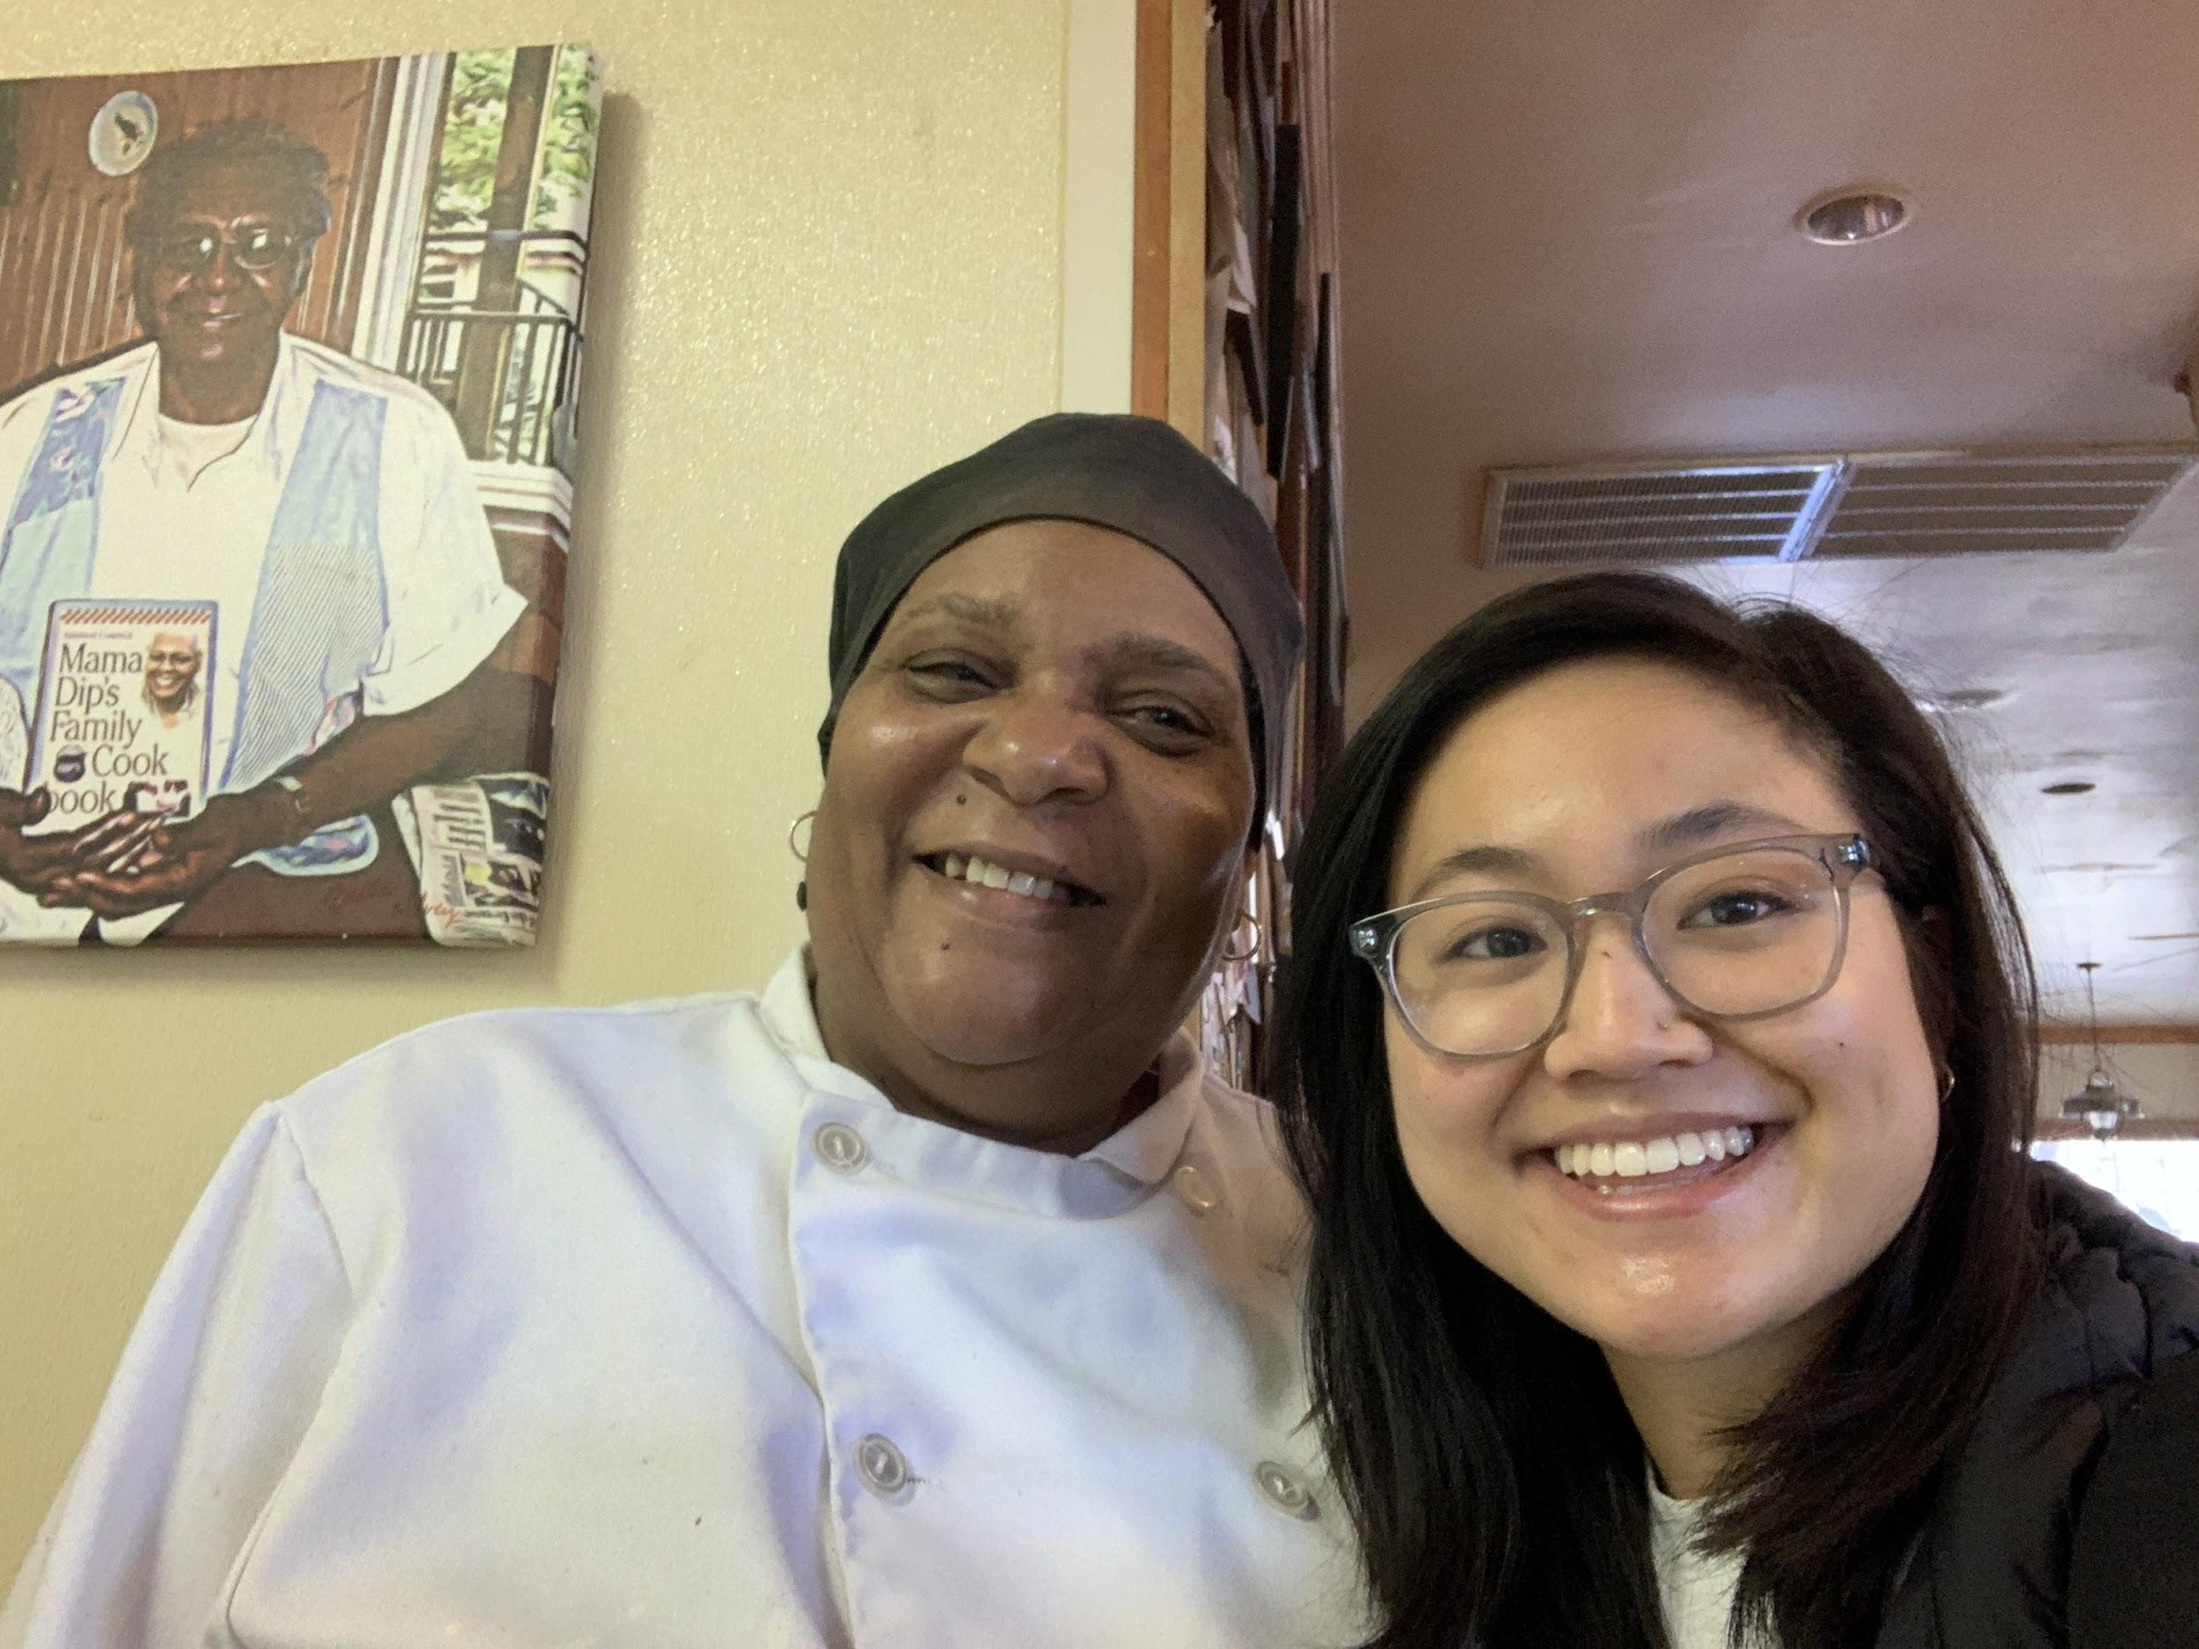
Northside neighbor, Joyce Yao, talked with Ms. Lane Council about her love of food and a life nurtured by her mother, community icon Mama Dip.

Ms. Lane Council so palpably embodies the vibrant spirit of a southern Black chef and business woman. She weaves together the energy required to be the head of a successful restaurant and the natural disposition of the daughter of a southern Black woman who taught her how to love food and feeding people. The legacy of Mama Dip is strongly championed by Ms. Council. “I have to do what she did. I feel like she’s in me so I have to carry on her legacy.” Even her preparation of cornbread is defended as a deeply-held belief. When I asked her about corn kernels in cornbread, she gave me a look and said, “Nuh uh. We ain’t doing that. No, no, no, my mama never did that. My sister likes her muffins with corn in it. But me, I like the way my mama did it. That’s why they call me Lil’ Dip!” -- Joyce Yao
Find Joyce’s complete story of her interview with Ms. Council, as well as Mama Dip’s Apple Cake Recipe on the Jackson Center website: jacksoncenter.info/blog/blog/

Introducing the Compass Center for Women and Families

Compass Center has been a part of the downtown community since it was formed in 2012 as part of a merger of two strong Chapel Hill agencies--the Women’s Center and the Family Violence Prevention Center for Orange County. We now serve more than 7,500 community members annually through youth empowerment programs, financial, career, and legal guidance, domestic violence crisis and support services, and by connecting the community to valuable resources. All of our services are free and voluntary.
We are especially proud of the work we do with the youth in our community through our adolescent programs - Teens Climb High and Start Strong. Teens Climb High offers participants in the Chapel Hill Carrboro area with a comprehensive, evidence-based program, Making Proud Choices! - a curriculum that provides safer-sex approach to teen pregnancy and HIV/STD prevention. Start Strong, a teen dating violence prevention program, offers sessions on healthy, unhealthy, and abusive relationship dynamics for 6th and 8th grade students. You can learn more about our services at www.compassctr.org.
-- Pallavi Sukhia

________________________

“Your story is your glory!”*
Members of the Jackson Center Community Mentor Team visited local schools during Black History Month to talk about their experiences during and after segregation. Here are some of the words they shared at McDougle Middle, Frank Porter Graham Elementary, and Carrboro Elementary:
Ms. Freda Andrews: "Living in Chapel Hill allowed us to experience the best of times and some of the worst of times. Back then, if you were white, you were alright. If you were brown, maybe you could stick around. But if you were black, you better get back.”
Ms. Gwen Atwater: “When it’s time for Black History Month, I always say we are black 365 days of the year."
Ms. Gladys Brandon: “First you’ve got to love yourself. Tell yourself: I am worthy to be in this big world and I can do anything I want to do.”
Ms. Carolyn Briggs: “When people have different opinions, it’s up to you to figure out what’s right. When you see you’re wrong, you have to be able to change your views.”
Ms. Pat Jackson: “Let’s just be clear. Whose town is this? This is MY town!”
Rev. Albert Williams: “Here’s the question: When you see something that isn’t right, what will YOU do?”

* Quote from Ms. Freda Andrews

In Memoriam
Ms. Dottie Bobo
Ms. Dottie Pendergraft Bobo passed away on February 6 after living for more than 103 years in Chapel Hill. She was a member of St. Paul A.M.E. Church and worked for many years as an elevator operator at the Carolina Inn. She was married only a few years to Mr. Harry Stroud, then married Chester Bobo. They divorced and, though she never had children, she loved her 15 nieces and nephews and helped support their education. She is survived by many nieces, nephews and their children and grandchildren as well as by her sister-in-law, Ms. Sallie Pendergraft, who is 101 and lives in Northside.

Ms. Patricia Farrington
Ms. Patricia Farrington, daughter of Rosa and the late Roger Farrington, passed away peacefully on February 26, 2020 at the age of 66. She was an exceptionally gifted, creative woman and a beloved teacher in Chapel Hill who continued to work at Ephesus Elementary even after she officially retired. One of her sons, Enrico Farrington, Sr., preceded her in death. She leaves behind her mother, her son, Desmond Alston, seven siblings, and seven grandchildren. Her many friends, family members, colleagues, and students celebrated her life in a service at First Baptist on February 29.

April Birthdays
4/6 Matthew Fearrington
4/17 William Page
4/22 Nikki Harmony, Seth Kotch
4/23 Calvin Neville
4/24 Prince Taylor, Frederic Williams
4/25 Odessa Williams
4/26 Christian Foushee
4/28 Michael Palmer

Opportunities!
- G.E.M.S. is an 8-week series of activities open to young women (ages 14-21) to explore opportunities in community-oriented careers in public safety and local government. Focus is on leadership, professional skill building, and community engagement. All sessions and field trips are free. Meals provided! Sessions are 6-8 pm on Tuesdays from 3/17- 4/12, 2020, at the CHPD.
- HOPE RENOVATIONS is offering free, 12-week construction job training program for women to learn the basics of painting, carpentry, electrical work, plumbing, and other trade skills. No experience is necessary. To apply, www.HopeRenovations.org/apply or call 919-921-8460.
- CODE THE DREAM, a non-profit located in RTP, provides a pathway to a tech career for people who might not otherwise have the opportunity, particularly minority and immigrant young people, ages 18+. Application deadline for next free coding class is March 29 for class beginning on May 18. Go to www.codethedream to apply.

“Discourse” World Premiere at Carolina Performing Arts @ Current Art Space
Tickets

In this emotionally resonant new work from flute and electronics duo Flutronix, the voices and personal stories of Chapel Hill are brought to vibrant life.
Apr 2 @ 7:30 pm – 8:30 pm

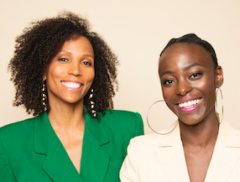
“Discourse” World Premiere at Current Art Space/Carolina Performing Arts
April 2, 2020 @ 7:30-8:30 pm
In this emotionally resonant new work from flute and electronics duo Flutronix, the voices and personal stories of Chapel Hill are brought to vibrant life.

