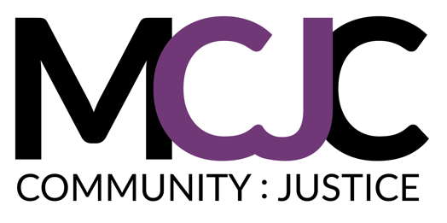
The Marian Cheek Jackson Center

Position announcement: Aging in Community Specialist

About the Position:
The Marian Cheek Jackson Center (MCJC) is seeking a part-time (15-20 hrs/wk) coordinator for up to 2 years to help implement our community-led initiatives focused on supporting elders in the community. This position will focus on three primary goals, all enabled through deep partnerships: 1) Refine our pilot intergenerational care networks program to provide the basis for volunteer care, 2) Support our Northside Residential Fellowship program, improving its connection to Northside elders, and 3) Organize key neighbors and partners in the design of eldercare housing and support options.

About the Northside Partners in Eldercare:
Northside Partners in Eldercare is a project of the Northside Neighborhood Initiative involving the Jackson Center, Self-Help, UNC’s Partnerships in Aging, and the Charles House Association. For nearly three years, we have worked with neighbors and partners to design models for affordable supports and services in Northside that would enable residents to age in the neighborhood and avoid institutional care. We have realized that developing and improving the intergenerational care networks in the community are essential for any such model to be possible. Thus, we are seeking a coordinator who can help us implement critical steps toward this ultimate goal, all the while improving an array of programs that are central to our long-term neighbor retention strategies.

Primary responsibilities of the Eldercare Coordinator:
- Manage and refine the Linking Generations in Northside (LINK) program
  - Serve as primary manager for this collaborative intergenerational care networks program, which connects UNC students with Northside elders in ongoing, mutually supportive relationships
  - Refine program model using evaluation feedback from the pilot program
  - Work with partners to recruit student and elder participants for year two of the LINK program
  - Organize student trainings and connective events alongside UNC’s Partnerships in Aging Program

- Support our graduate student living-learning household focused on student engagement with community elders
  - Provide support and accountability for the Northside Residential Fellows, three graduate students in our “living-learning community”
  - Meet monthly with Fellows to review progress toward community agreements and coordinate events and other connective opportunities
  - Manage the Fellows role as the primary ‘site committee’ for a new tiny-home duplex that will serve 2 seniors who are at risk for homelessness.

- Coordinate efforts to develop models of affordable, long-term community care that are vetted and augmented by all stakeholders, including neighbors, health professionals, UNC students/faculty, and housing providers.
  - Complete project designs for at least two housing and service models

Qualifications:
Ideal candidates will:
- Be well-organized, adept at creative problem-solving, and committed to community-based solutions;
- Experience and skills in social justice issues applied in underserved neighborhoods.

Key Attributes:
- Listening-centered: You believe in the power of listening as the primary mode of community building & organizing;
- Process-oriented: You have the technical capacity for systems management and the consistency to maintain current processes effectively;
- Great communicator: You have excellent writing, editing, and facilitation skills and the ability to communicate effectively with a wide range of partners, neighbors, and stakeholders;
- Sense of humor: You find lightness in the work and take joy in the nuts and bolts of pursuing community justice;
- Accountable: You work well independently within the context of a team environment and hold yourself and co-workers to high standards, always with a good dose of grace; and,
- Relationship-centered & community-driven: Have an investment in local Black history as told by the people who made it. Your relationships with and commitment to community fuels your energy.

Additional information:
This is a part-time position with pay depending on experience and credentials. The Jackson Center is a great work environment, with vibrant staff who are committed to living the mission of our work. The Jackson Center is an equal opportunity employer, and strongly encourages applications from people of color, persons with disabilities, women, and LGBTQ applicants. For further information about the Center and its programs, please see our website at www.jacksoncenter.info or contact Hudson Vaughan, Interim Executive Director, at hudson@jacksoncenter.info.

To apply:
Send a 1-2 page cover letter to apply@jacksoncenter.info, subject line: Aging in Community Specialist, explaining your interest in and qualifications for the position. Please attach a resume including 3-4 relevant references with contact information. References will only be contacted after interviews. Applications for this position are being received currently. Applications will be reviewed on a rolling basis until the position is filled.

